NOTE TAKING APPLICATION

Main menu

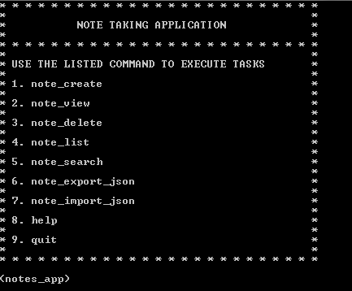

note_list

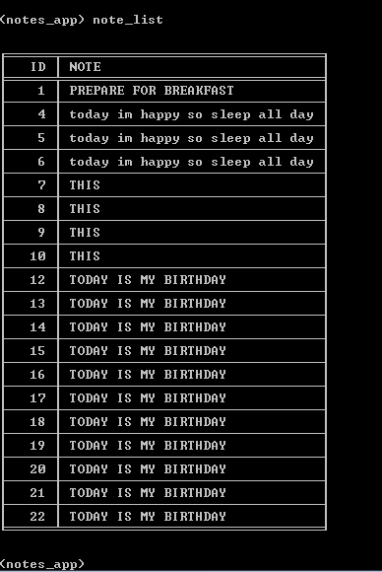

note_delete 1

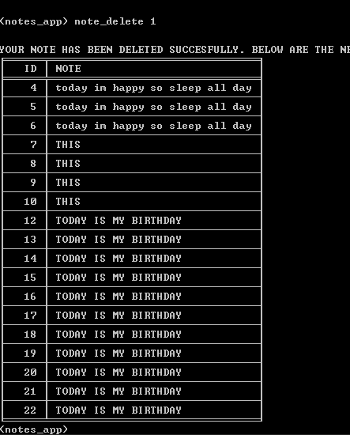

note_view 12

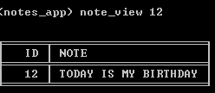

note_search BIRTHDAY

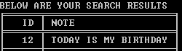

export_json mydata

